CS6650 Homework 5 Report
1) Repository Setup
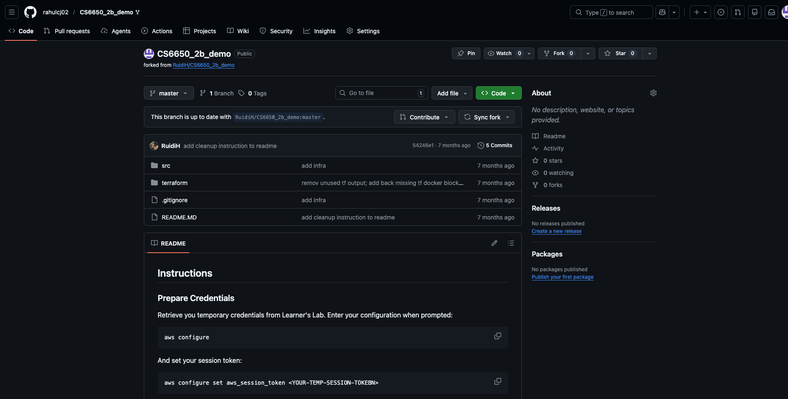
Figure 1. Forked GitHub repository (CS6650_2b_demo).
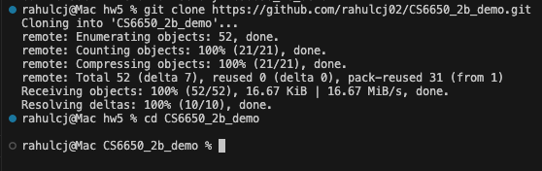
Figure 2. Successful clone of the forked repository.
2) Product API Validation (Local)
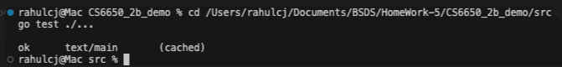
Figure 3. Unit tests passing (`go test ./...`).
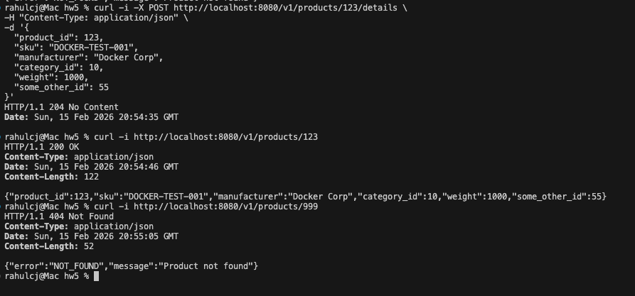
Figure 4. Local curl responses showing required HTTP codes (200, 204, 404, 400).
Figure 5. Additional API validation output

3) Container Build and Image Workflow
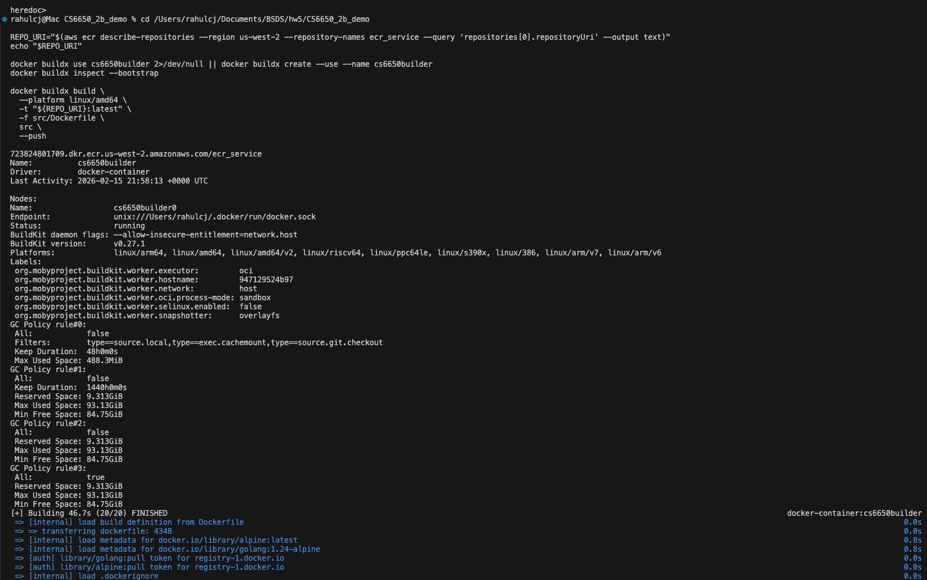
Figure 6. Docker build/buildx output for application image.
4) Terraform Deployment and AWS Verification
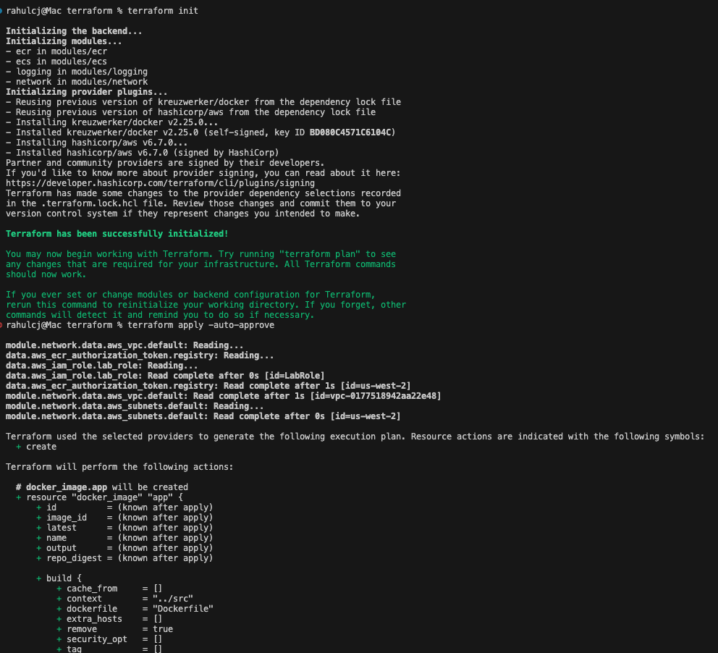
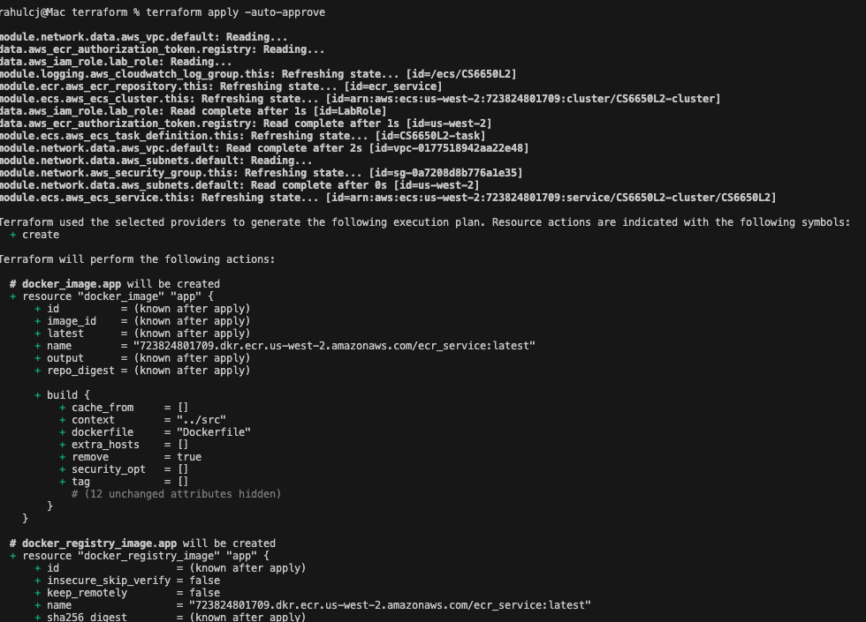
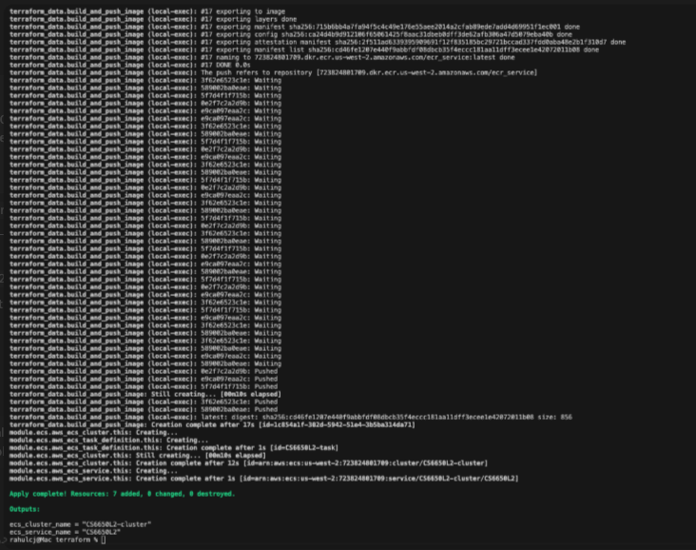
Figure 7. Terraform apply execution output.
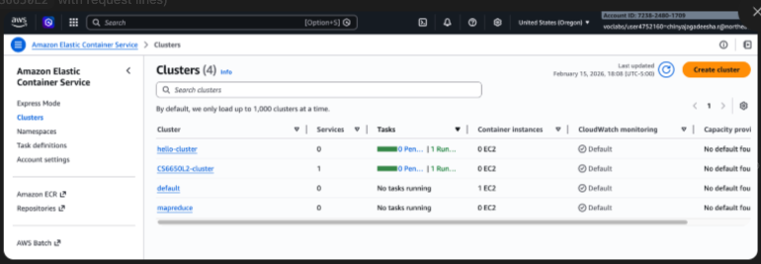
Figure 8. ECS service/task status evidence from CLI.
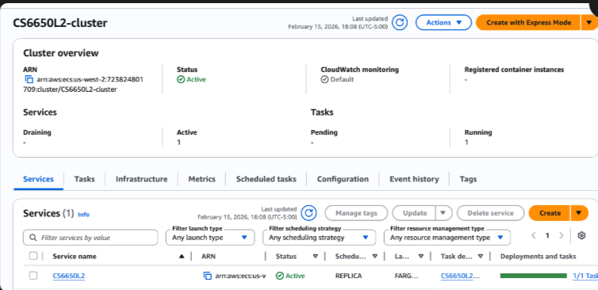
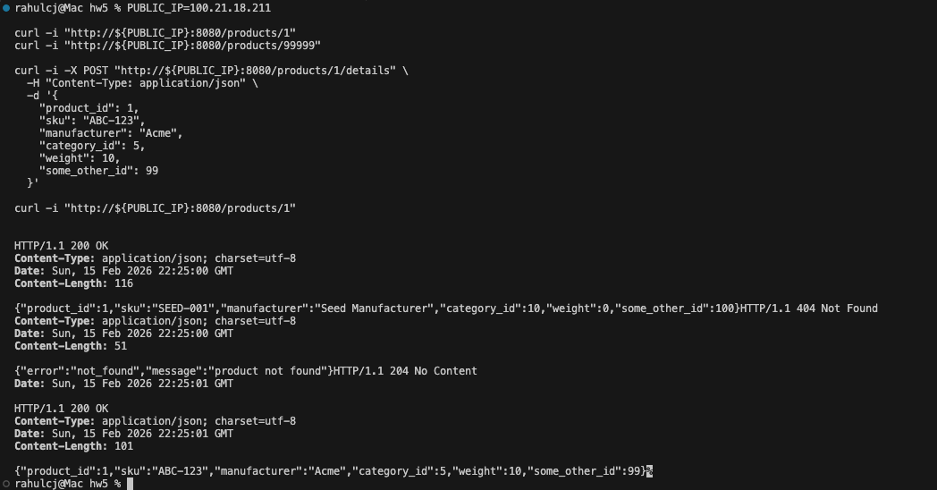
Figure 9. Public IP retrieval and deployed API curl verification.
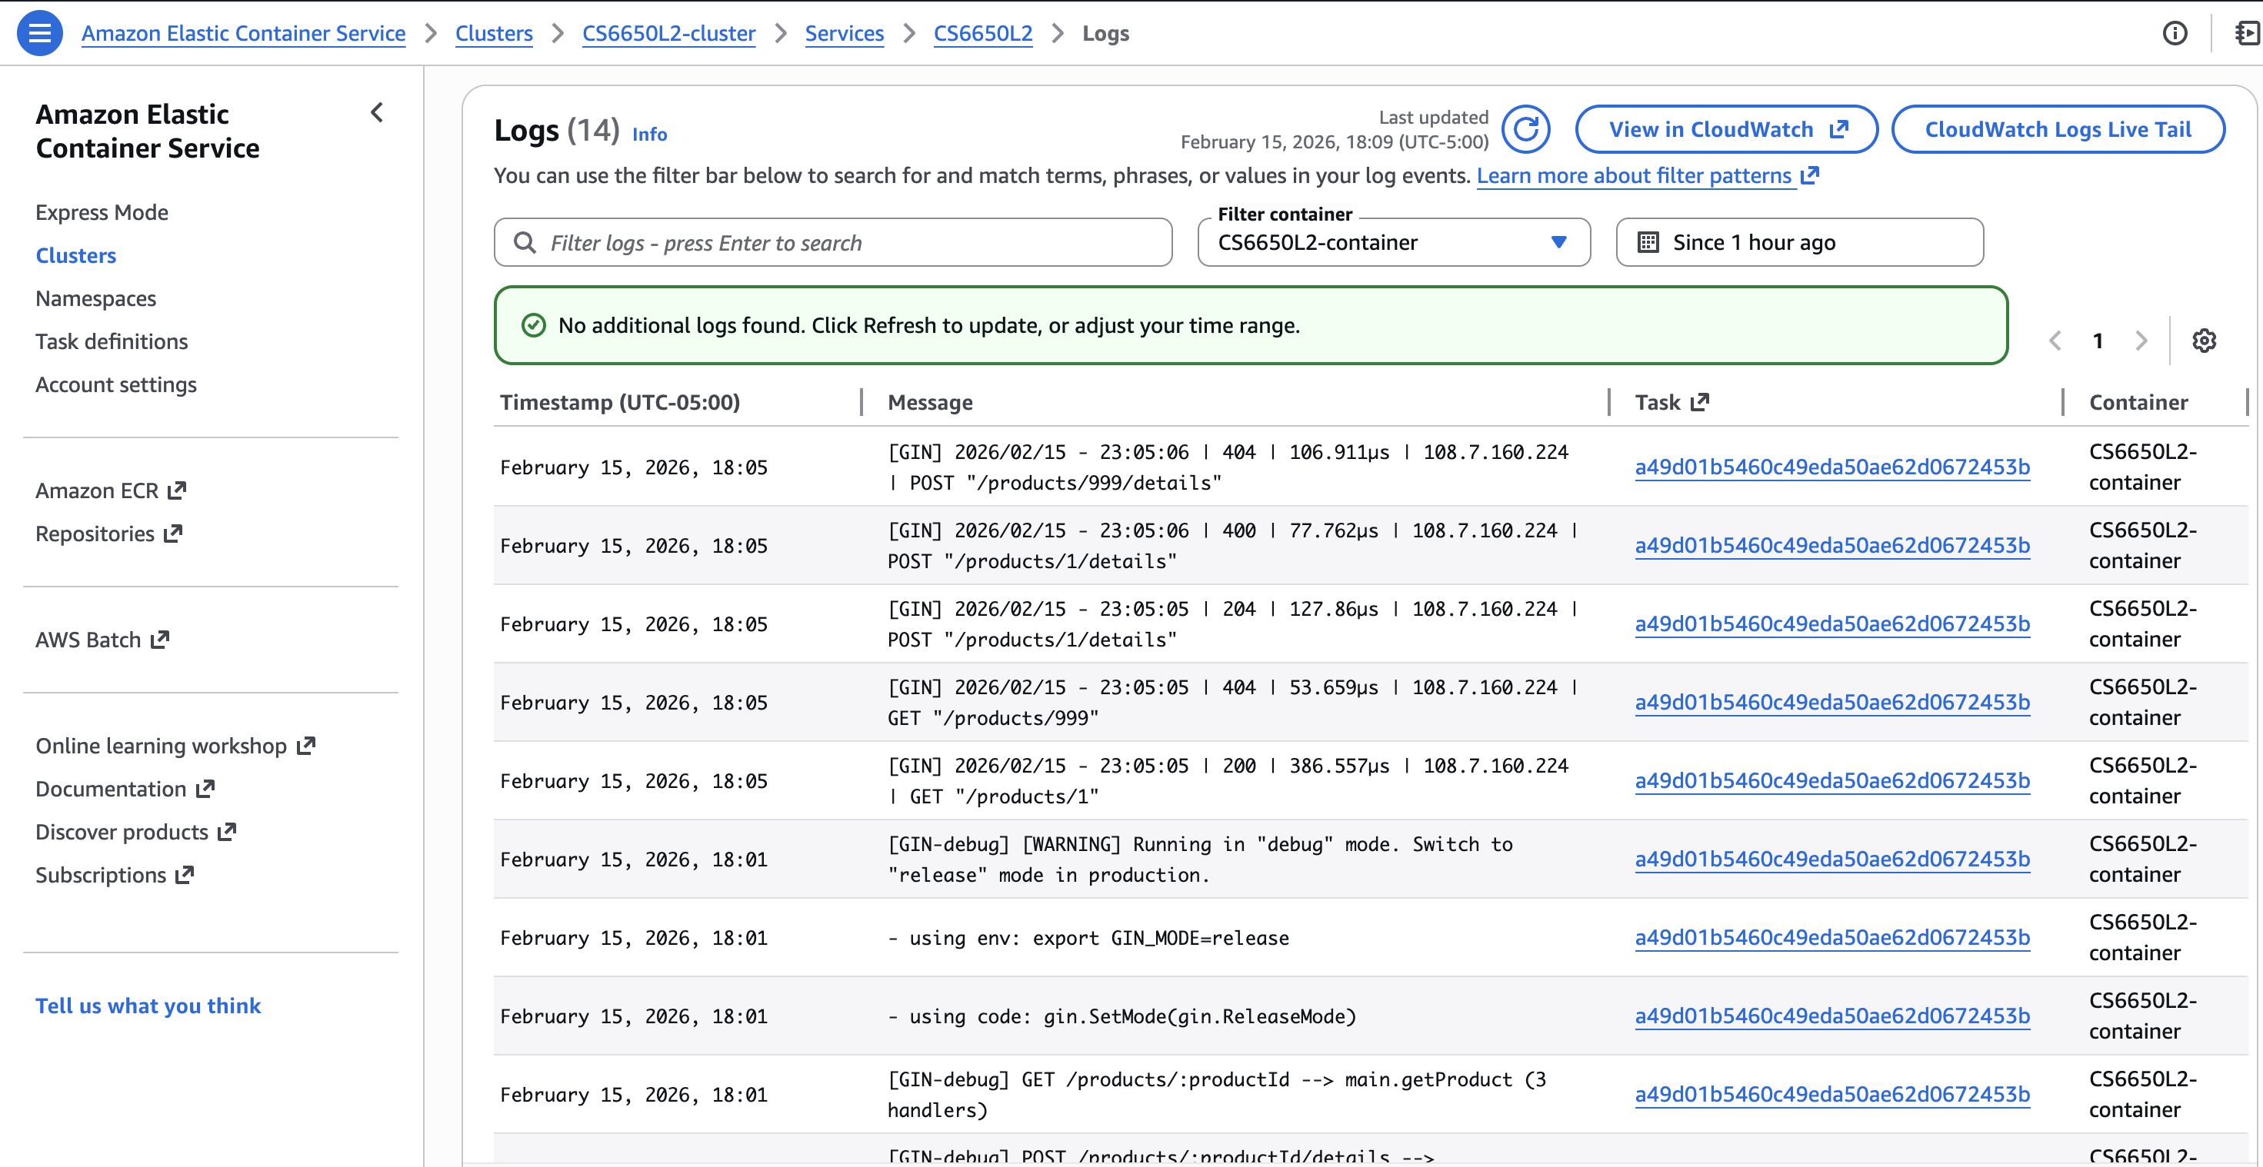
Figure 10. CloudWatch logs confirming application traffic and responses.
5) Load Testing with Locust
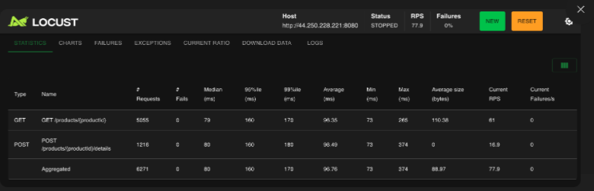
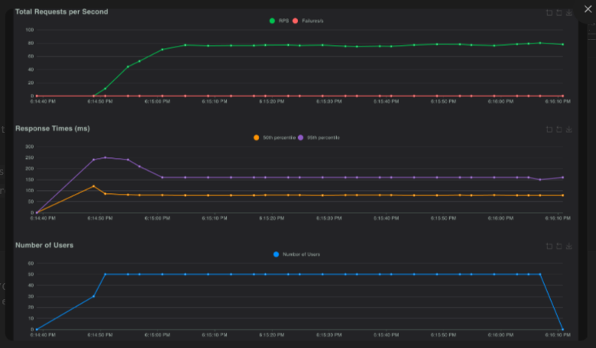

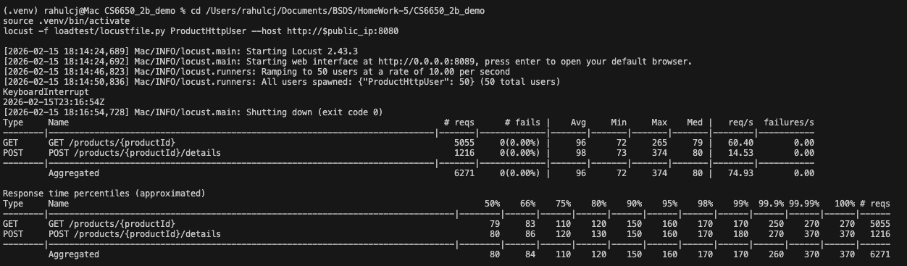
Figure 11. ProductHttpUser results (statistics, charts, and terminal summary).
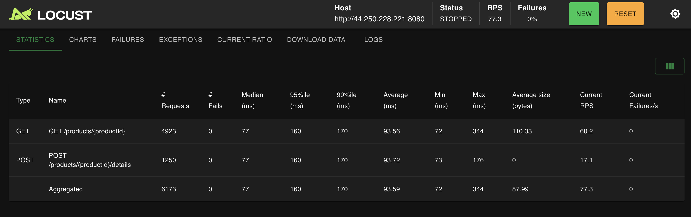

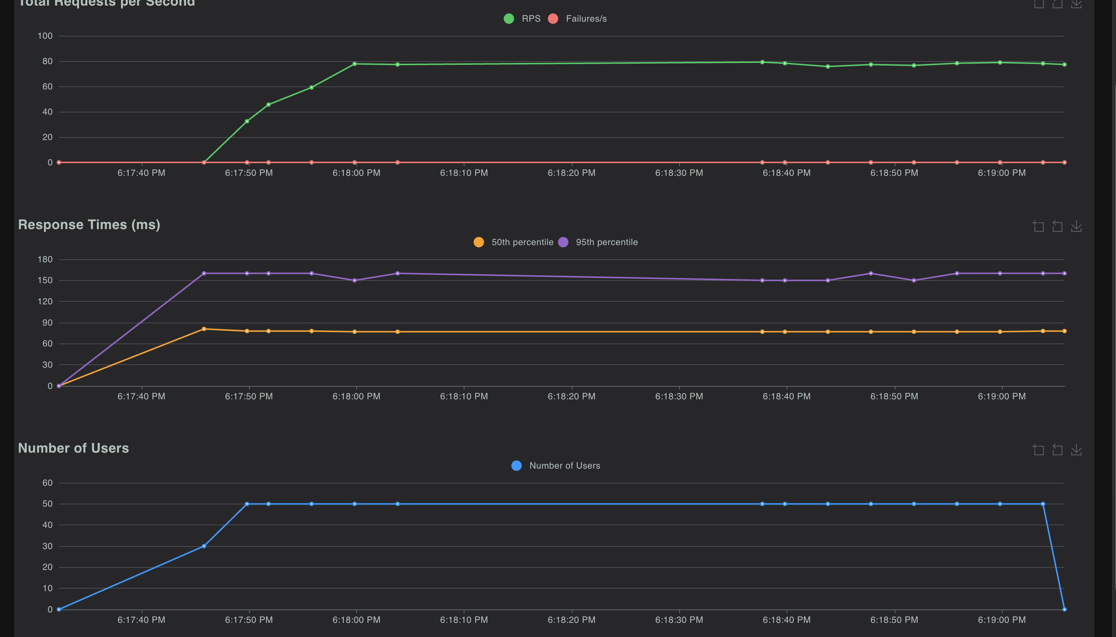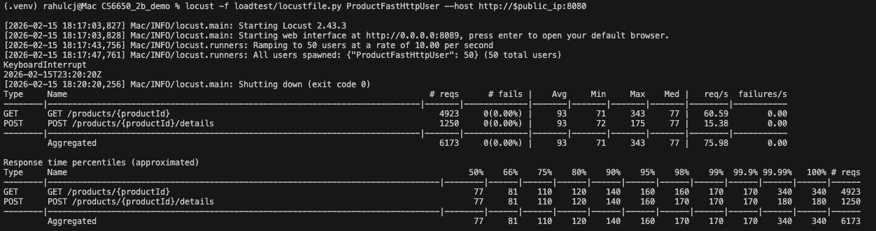
Figure 12. ProductFastHttpUser results (statistics, charts, and terminal summary).
Load-test summary: both test types completed with 0 failures. FastHttpUser achieved slightly higher throughput in this run; behavior is close overall due to backend/network-bound workload.
Q1: Which operations are most common, and what data-structure tradeoff applies here?
A1: Read operations (`GET /products/{productId}`) are typically more frequent than writes. An in-memory hashmap with RWMutex gives O(1) lookup/update and suits this assignment scale.
Q2: Why are HttpUser and FastHttpUser results close in this assignment?
A2: The bottleneck is mostly server/network time rather than client-library overhead, so both clients show similar RPS/latency at this concurrency and payload size.
Q3: How would a scalable backend for the full api.yaml be designed (high level)?
A3: Split by domain services (products, cart, inventory, orders, payments), place an API gateway in front, use durable databases, async queues/events, and centralized observability with logs/metrics/tracing.
Q4: What does Terraform being declarative mean?
A4: Declarative means defining the desired end state; Terraform computes and applies the changes to reach that state. Imperative approaches require step-by-step command logic.
6) Infrastructure Cleanup

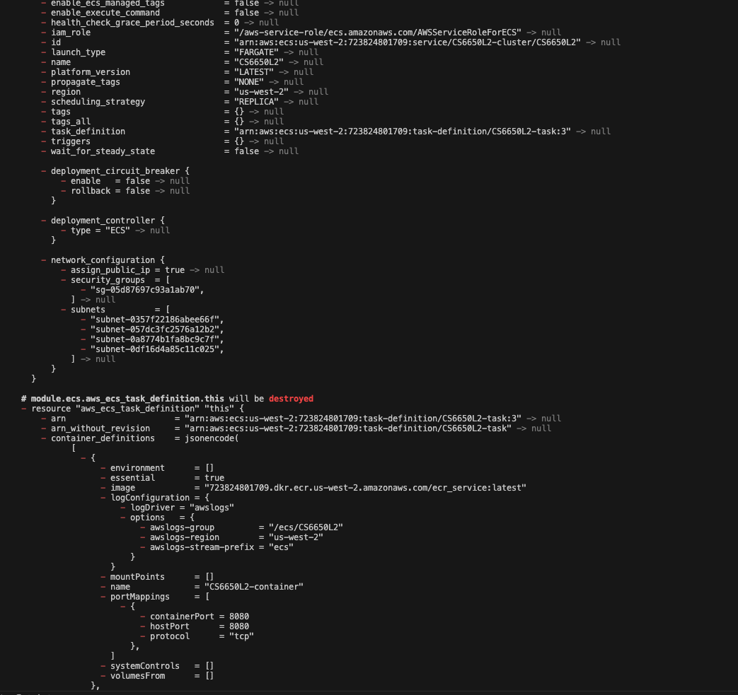

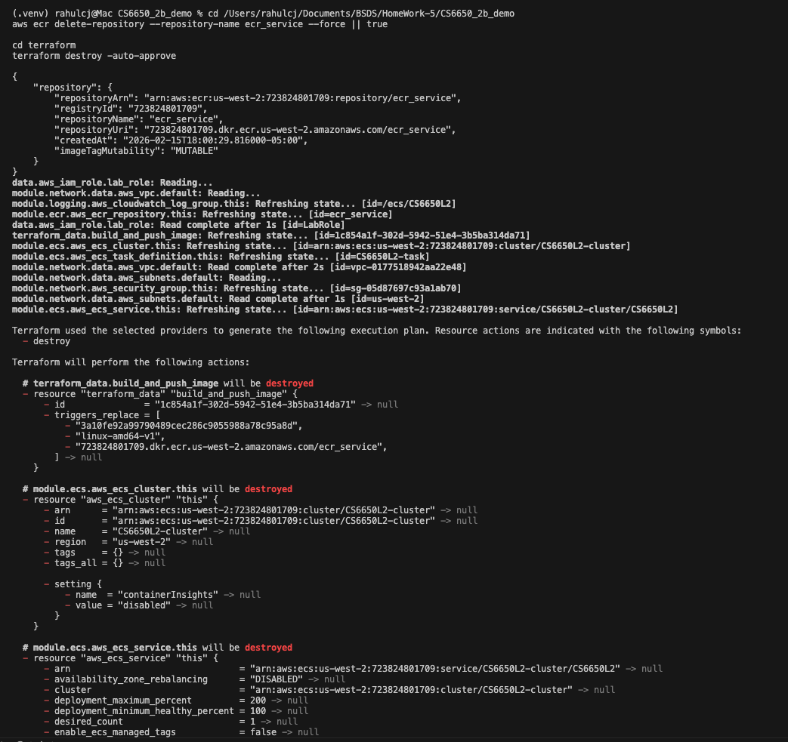
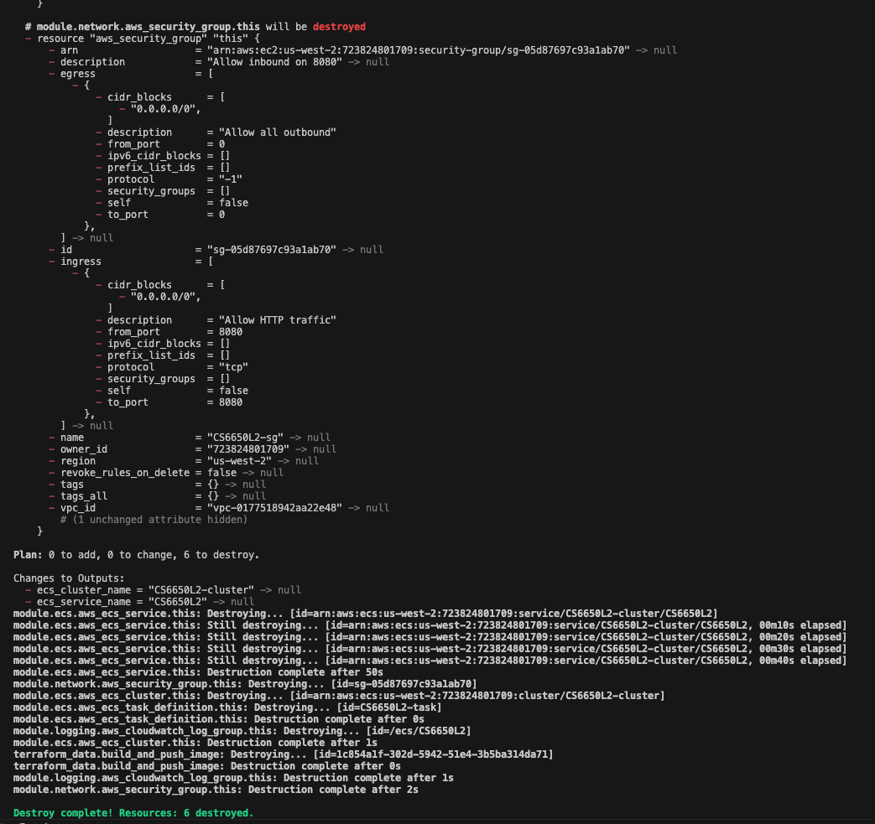
Figure 13. Terraform destroy.
Cleanup completed and deployment resources were torn down as shown in the terminal output sequence.

